
Sukkur Institute of Business Administration University
Department of Computer Science

Programming Fundamentals (C++)

BS – I (Computer Science - D)

Fall 2025

Instructor: Nisar Ahmed Siddiqui

LAB # 02

Submission Profile

Name: Abdul Wasio
CMS ID: 023 - 25 - 0007
Date: 07th September 2025
Receiving Authority: Sir Nisar Ahmed Siddiqui

PROGRAMMING FUNDAMENTALS
TABLE OF CONTENTS
03
Activity
06
Exercise 1
08
Exercise 2

09
Exercise 3

10
Exercise 4

10
Exercise 5
11
Exercise 6

Activity
Write a program in which you declare and initialize all the countable and measurable datatypes provided by dev-C++ compiler. Moreover, you are required to print the minimum and maximum range of values that can be stored in those variables along with the space occupied by those variables in the memory.


Program
#include<iostream>
#include <climits>
#include<cfloat>
#include<float.h>

using namespace std;
int main(){
short s1=2;
unsigned short s2=5;
signed short s3=6;
int i1=1;
signed int i2=-5;
unsigned int i3=9 ;
long l1=1234;
unsigned long l2= 368736;
signed long l3= -123456;
long long ll1=3827582;
unsigned long long ll2=13892473;
signed long long ll3=-18787576;
float f1=9.776;
double d2=6.8367843;
long double d3=72.2724782;
char c1='A';
signed char c2='B';
unsigned char c3='C';
cout << "Check the upper and lower limits of countable datatypes :\n";
cout << " \n";
cout<<"The Maximum limit of Short is: "<<SHRT_MAX;
cout<<"\nThe Minimum limit of Short is: "<<SHRT_MIN;
cout<<"\nThe Maximum limit of Int is: "<<INT_MAX;
cout<<"\nThe Minimum limit of Int is: "<<INT_MIN;
cout<<"\nThe Maximum limit of Signed Int is: "<<INT_MAX;
cout<<"\nThe Maximum limit of UnSigned Int is: "<<UINT_MAX;

cout<<"\nThe Maximum limit of Long is: "<<LONG_MAX;
cout<<"\nThe Minimum limit of Long is: "<<LONG_MIN;
cout<<"\nThe Maximum limit of Singed Long is: "<<LONG_MAX;
cout<<"\nThe Minimum limit of Singed Long is: "<<LONG_MIN;
cout<<"\nThe Maximum limit of UnSinged Long is: "<<ULONG_MAX;
cout<<"\nThe Maximum limit of Long Long is: "<<LLONG_MAX;
cout<<"\nThe Minimum limit of Long Long is: "<<LLONG_MIN;
cout<<"\nThe Maximum limit of Singed Long Long is: "<<LLONG_MAX;
cout<<"\nThe Minimum limit of Signed Long Long is: "<<LLONG_MIN;
cout<<"\nThe Maximum limit of UnSinged Long Long is: "<<ULLONG_MAX;
cout<<"\nThe Maximum limit of Float is: "<<FLT_MAX;
cout<<"\nThe Minimum limit of Float is: "<<FLT_MIN;
cout<<"\nThe Maximum limit of Double is: "<<DBL_MAX;
cout<<"\nThe Minimum limit of Double is: "<<DBL_MIN;
cout<<"\nThe Maximum limit of Long Double is: "<<LDBL_MAX;
cout<<"\nThe Minimum limit of Long Double is: "<<LDBL_MIN;
cout<<"\nThe Maximum limit of Character is: "<<CHAR_MAX;
cout<<"\nThe Maximum limit of Signed Character is: "<<SCHAR_MAX;
cout<<"\nThe Minimum limit of Signed Character is: "<<SCHAR_MIN;
cout<<"\nThe Maximum limit of UnSigned Character is: "<<UCHAR_MAX;

cout << "\n\nCheck the space of memory occupied by countable datatypes :\n";

cout<<"\nThe Size of Int is: "<< sizeof(i1);
cout<<"\nThe Size of Signed Int is: "<< sizeof(i2);
cout<<"\nThe Size of UnSigned Int is: "<< sizeof(i3);
cout<<"\nThe Size of Short is: "<< sizeof(s1);
cout<<"\nThe Size of UnSigned Short is: "<< sizeof(s2);
cout<<"\nThe Size of Signed Short is: "<< sizeof(s3);
cout<<"\nThe Size of Long is: "<< sizeof(l1);

cout<<"\nThe Size of UnSinged Long is: "<< sizeof(l2);
cout<<"\nThe Size of Signed Long is: "<< sizeof(l3);
cout<<"\nThe Size of Long Long is: "<< sizeof(ll1);
cout<<"\nThe Size of UnSigned Long Long is: "<< sizeof(ll2);
cout<<"\nThe Size of Signed Long Long is: "<< sizeof(ll3);
cout<<"\n";
system("pause");
return 0;

}

Output
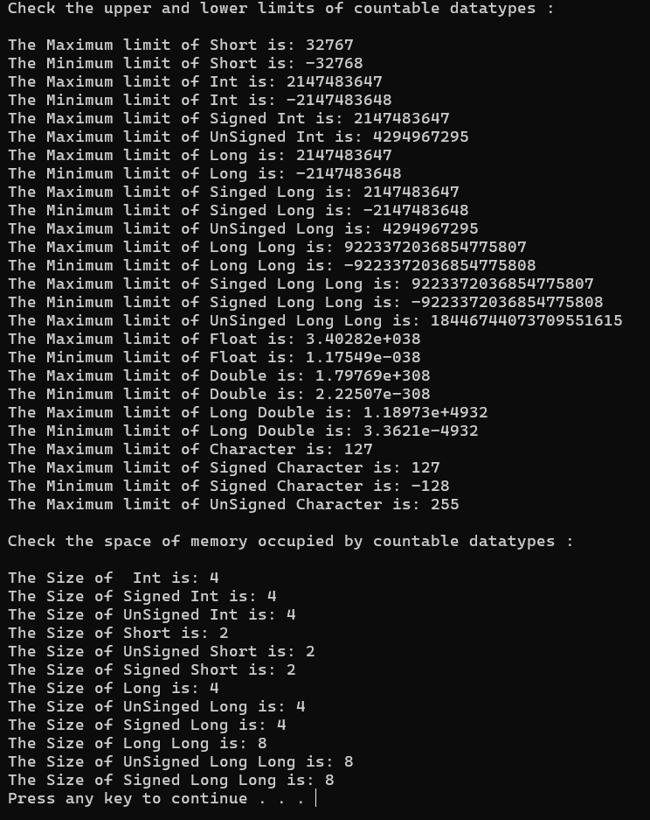

Exercise 1
Write a program that takes 5 values from user. Two values of integer and two values of float and one value of char data type. Print each result on a separate line.

Program
#include <iostream>
using namespace std;
int main() {
int a, b;
float c, d;
char e;
cout << "Enter INT - 1: ";
cin >> a;
cout << "Enter INT - 2: ";
cin >> b;
cout << "Enter Float - 1: ";
cin >> c;
cout << "Enter Float - 2: ";
cin >> d;
cout << "Enter Character: ";
cin >> e;
cout << "INT - 1: " << a << endl;
cout << "INT - 2: " << b << endl;
cout << "Float - 1: " << c << endl;
cout << "Float - 2: " << d << endl;
cout << "Character: " << e << endl;
system("pause");

return 0;
}
Output
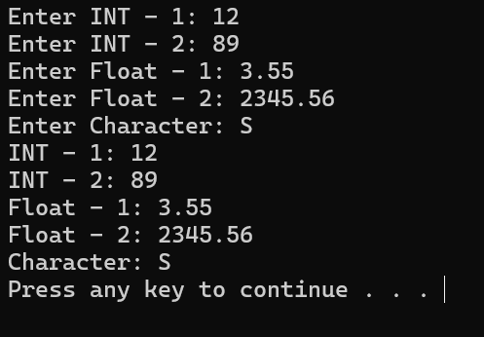

Exercise 2
Write a program that takes voltage and current from user, saves them in respective data types (I and R as float or double and V as int), and calculates Resistance as per the following formula:

Resistance = Voltage (V) / Current (C)

Program
#include<iostream>
using namespace std;
int main(){
double I,R;
int V;
cout<<"Enter Voltage(V) : ";
cin>>V;
cout<<"\nEnter Current(I) : ";
cin>>I;
cout<<"\nThe Value of Resistance(R) is : "<<V/I<<"\n";
system("pause");
return 0;
}

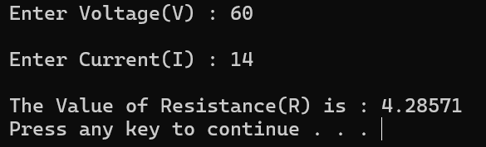
Output

Exercise 3
Write a program, in which you create three variables to set the marks (out of 100) for ICT, Math and English subjects for Ayaz. Afterwards, your program should calculate his obtained marks in all three subjects.
Program
#include<iostream>
using namespace std;
int main(){
float ict,math,eng,total;
ict=77.5;
math=54.1;
eng=78.7;
total = ict + math +eng;
cout<<"\t\tMARKSHEET\n";
cout<<"Ayaz ICT score out of 100\t:\t"<<ict;
cout<<"\nAyaz MATH score out of 100\t:\t"<<math;
cout<<"\nAyaz ENGLISH score out of 100\t:\t"<<eng;
cout<<"\nObtained Marks out of 300\t:\t"<<total<<"\n";
system("pause");
return 0;
}
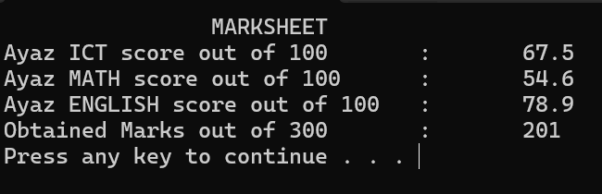
Output

Exercise 4
Write a program that asks the user to type character then the program will generate its ASCII value.
Program
#include<iostream>
using namespace std;
int main(){
char i;
cout<<"Enter the Character : ";
cin>>i;
cout<<"The ASCII Value of "<<i<<" is "<<int(i)<<"\n";
system("pause");
return 0;
}
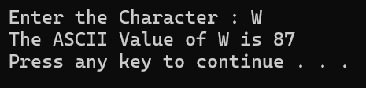
Output

Exercise 5
Write a program that asks the user to type lowercase (small) alphabet character then the program will generate its uppercase (capital) alphabet character.
Program
#include<iostream>
using namespace std;
int main(){
char c;
cout<<"Enter the Lowercase alphabet character : ";
cin>>c;
cout<<"The Uppercase of "<<c<<" is "<<char(c-32)<<"\n";
system("pause");
return 0;
}
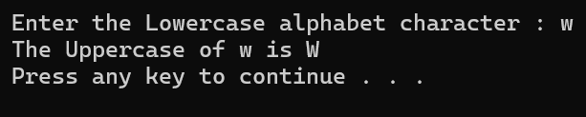
Output

Exercise 6
Write a program that asks the user to type uppercase (capital) alphabet character then the program will generate its lowercase (small) alphabet character.
Program
#include<iostream>
using namespace std;
int main(){
char c;
cout<<"Enter the Uppercase alphabet character : ";
cin>>c;
cout<<"The lowercase of "<<c<<" is "<<char(c+32)<<"\n";
system("pause");
return 0;
}

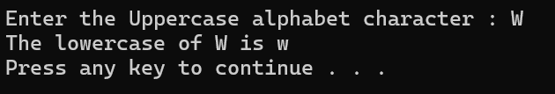
Output

